**Abstract****:** Digital Logic Design is the one of the introductory courses for Electrical and Electronics Engineering students. It can introduce students to circuit design, problem solving, testing, and feature verification. In this experiment, students were asked to design and construct **Priority Encoder, Decoder & Multiplexer** and simulate the vector waveforms. They also verified the truth table with the simulated results. And they also learned behavioral Verilog coding of Priority Encoder, Decoder & Multiplexer using procedural model and continuous assign statement. Here, they also learned to implement and test encoder & decoder using discrete gates and get to know the uses of these. The digital logic design lab is a learning experience that most students enjoy because it gives them their first hands-on experience designing and constructing miniature structures.

Intro: 2n discrete symbols or elements of coded information can be represented by a binary code of n bits. Encoders are digital circuits that perform digital information decoding, while decoders are digital circuits that decode the coded digital information. An encoder with enable pins is called multiplexer while a decoder with enable pins is called demultiplexer. Discrete inputs to digital systems are encoded to binary-coded form by encoder circuits. In a reverse process, binary coded data are decoded to decoded to discrete information by decoder circuits. Multiplexer means transmitting many information units over a smaller number of channels or lines.

**Encoder****:** The encoder is a circuit, a device, or a transducer. The encoder converts data from one format to another, such as electrical signals to counters or a PLC, for example. A binary encoder, also known as a digital encoder, is a combinational circuit capable of converting "2n" input signals into "n" signals (such as BCD (Binary Coded Decimal) Binary). It works in the exact opposite way as Binary Decoder. In simple terms, a Binary Encoder is a device that is used to encode binary codes.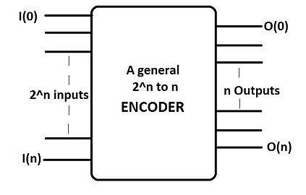

Uses:

* We use an encoder when we need to process data from a large number of data lines but only have a few input ports.
* Aerospace: Encoders provide high-precision motion feedback while operating in extreme environmental conditions.
* Autonomous Vehicles & Robots: Encoders provide precise, reliable motion feedback in automated robotics applications.
* encoder ensures that the unit to be controlled, such as a machine tool, does not exceed a preset position or direction of travel.
* Ball Screw Positioning: Attached to the end of the ball Screw shaft or drive motor, encoder provide motion feedback.
* In textiles it provide feedback for speed, direction, and distance for precisely controlled operations.
* Conveying: Applied to drive motor, to a head-roll shaft to a pinch-roller, or to a lead screw.
* Cut-to-length: Generates fixed number of pulses, sends them to the controller, which determines length of travel.
* Filling: Encoders ensure that the item to be filled is in the correct position before the filling mechanism activates.
* Food & Beverage: Provide feedback for processing, filling, packaging, material handling, labeling etc.
* Printing: Provide feedback in a variety of automated machinery used in the printing industry.
* Textiles: Provide critical feedback for speed, direction and distance.
* X-Y positioning: Provide feedback on two axes of motion to determine X-Y coordinates.

**Priority Encoder**: The output of the priority encoder corresponds to the highest-priority input currently active. As a result, if a higher-priority input is present, all lower-priority inputs will be ignored.

Figure: 8-to-3 Priority Encoder

**Uses:** Used extensively in digital and computer systems as microprocessor interrupt controllers where they detect the highest priority input.

* used to reduce the number of wires needed in a particular circuits or **application** that have multiple inputs.
* **used** to control interrupt requests by acting on the highest **priority** interrupt input.
* It is useful for error checking:  A **priority encoder** overcomes this **disadvantage** of the binary **encoder**. It gives a coded output by assigning a **priority** to the bits of input. The lower **priority** bits' values don't matter.
* Another more common application is in magnetic positional control as used on ships navigation or for robotic arm positioning etc.
* Interrupt request: detect interrupts in microprocessor applications.

Decoder: The **decoder** is a circuit used to change the code into a set of signals. A **decoder** is a combinational circuit that converts binary information from n input lines to a maximum of 2^n unique output lines.  One of these outputs will be active High based on the combination of inputs present, when the **decoder** is enabled. That means **decoder** detects a particular code.

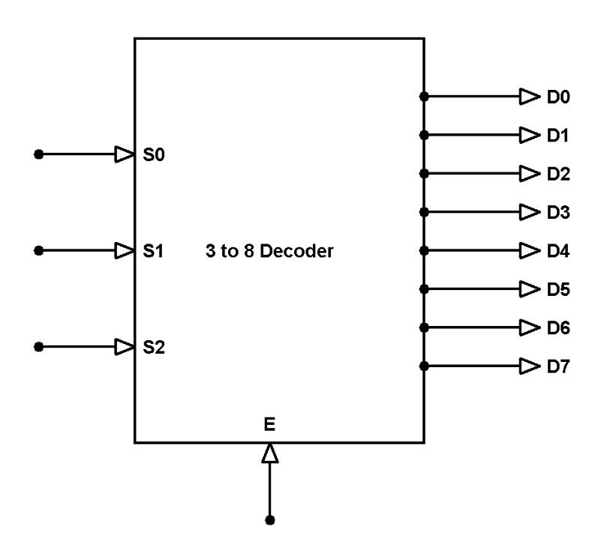

Figure: 3-to-8-line Decoder logic diagram

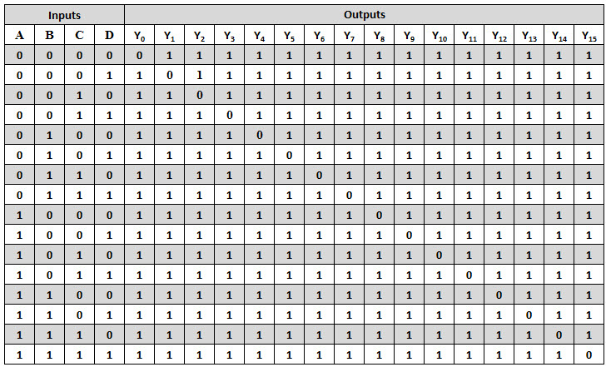

**Uses:**

* used in analog to digital conversion in analog **decoders**.
* Used in electronic circuits to convert instructions into CPU control signals.
* Mainly used in logical circuits, data transfer.
* when the **decoder** is enabled. That means **decoder** detects a particular code.

**Enable Input:** A chip-**enable input** is a clock or strobe **input** that significantly affects the power dissipation of the integrated circuit. For example, it may be the cycle control **input** of a dynamic memory or a power-reduction **input** of a static memory.

**Multiplexer:** The **multiplexer** is a device that has multiple inputs and single line output.  The select pins determine which input is connected to the output, and also increase the amount of data that can be sent over a network within a certain time. It is also called selection pin. If the input lines are n the selected pin will be ceil of log2(n). In example: In 12-to-1 line multiplexer, selected pins are log2(n)= log2(12)=ceil of 3.584. That means 4 selected pins.

a **multiplexer** (or **mux**; spelled sometimes as **multiplexor**), also known as a data selector, is a device that selects between several analog or digital input signals and forwards the selected input to a single output line.

**Multiplexer** means many into one. A **multiplexer** is a circuit used to select and route any one of the several input signals to a single output. A simple **example** of an non-electronic circuit of a **multiplexer** is a single pole multi-position switch.

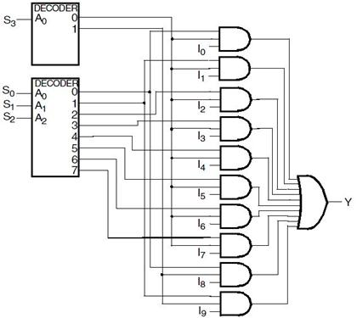

**Figure: 12 to 1 line multiplexer**

**Uses:**

* **used** to increase the quantity of data that can be transmitted over a network with a given bandwidth over a given period of time.
* A digital **multiplexer** has digital input signals coming from multiple data-acquisition networks.
* **used** to increase the efficiency of the communication system by allowing the transmission of data such as audio & video data from different channels via cables and single lines.
* **Communication System:** used in communication systems, which has a transmission system and also a communication network.
* **Computer Memory:** used in computer memory to keep up a vast amount of memory in the computers, and also to decrease the number of copper lines necessary to connect the memory to other parts of the computer.
* **Telephone Network :** used in telephone networks to integrate the multiple audio signals on a single line of transmission.
* **Transmission from the Computer System of a Satellite:** used to transmit the data signals from the computer system of a satellite to the ground system by using a GSM communication.

**Truth tables:**

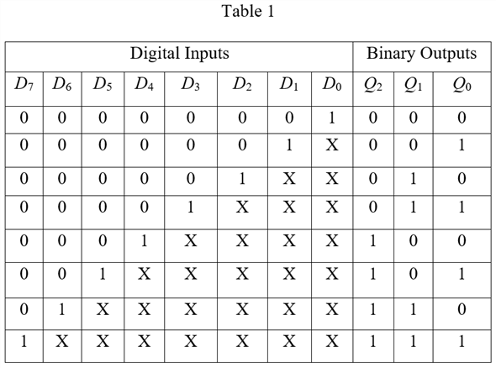

**

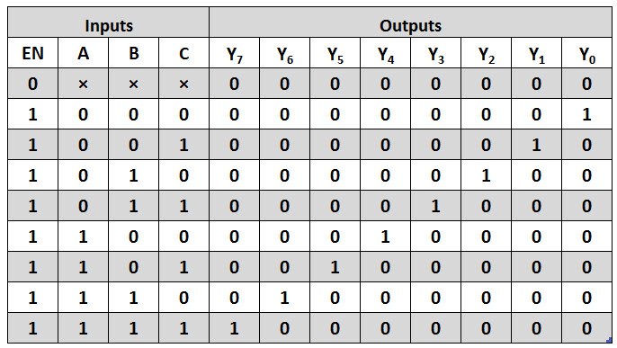

**3.** 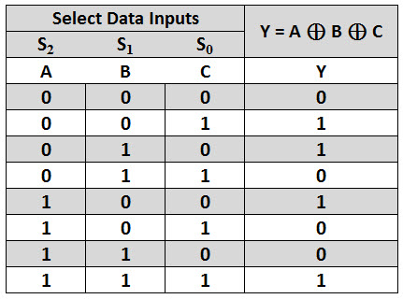

**Simulations:**

**Conclusion:**

Ref:

1. <https://www.electronics-tutorials.ws/combination/comb_4.html>

2. <https://www.encoder.com/encoder-applications>

3. <https://www.watelectronics.com/what-is-multiplexer-and-types/>